**PRACTICAL – 1**

**Objective :-** Print Hello world using printf.

**Printf :-** printf() function is used to print formatted output to the standard output **stdout**(which is generally the console screen).  The printf function is a part of the C standard library <**stdio.h>** and it can allow formatting the output in numerous ways.

**Program :** 1_Hello_World.c

#include <stdio.h>

int main ()

{

    printf("Hello world");

    return 0;

}

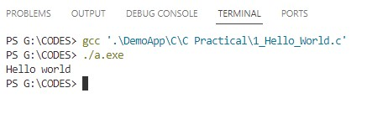**Output :**

**PRACTICAL – 2**

**Oblective** :- Find area of rectangle. Take length and width as input from user using scanf.

**Formula :** Area of Rectangle = length * width

**Scanf :-** scanf is a function that stands for Scan Formatted String. It is used to read data from stdin (standard input stream i.e. usually keyboard) and then writes the result into the given arguments. It accepts character, string, and numeric data from the user using standard input. scanf also uses format specifiers like printf.

**Program :** 2_Area_of_rect.c

#include <stdio.h>

int main ()

{

    float area, length, width;

    printf("Enter the length of rectangle : ");

    scanf("%f",&length);

    printf("Enter the width of rectangle : ");

    scanf("%f",&width);

    area = length * width;

    printf("Area of rectangle is : %g",area);

    return 0;

}

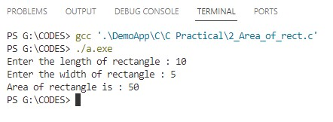**Output :**

**PRACTICAL – 3**

**Objective :-** Find area of squre. Take length as input from user using scanf.

**Formula :** Area of Square = (length)2

**Program :** 3_Area_of_square.c

#include <stdio.h>

int main ()

{

    float area, length;

    printf("Enter the length of square : ");

    scanf("%f",&length);

    area = length * length;

    printf("Area of square is : %g",area);

    return 0;

}

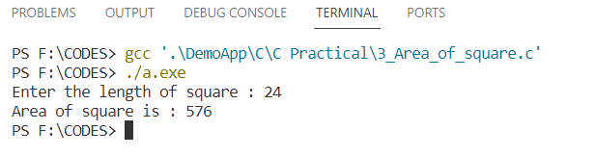**Output :**

**PRACTICAL – 4**

**Objective :-** Find area of circle. Take radius as input from user using scanf.

**Formula :** Area of Circle = *π* r2

**Program :** 4_Area_of_circle.c

#include <stdio.h>

int main ()

{

    float area, redius;

    printf("Enter the redius of circle : ");

    scanf("%f",&redius);

    area = 3.14 * redius * redius;

    printf("Area of circle is : %.2f",area);

    return 0;

}

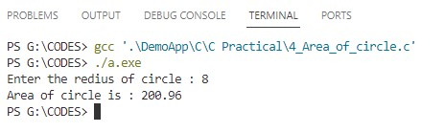**Output :**

**PRACTICAL – 5**

**Objective :-** Convert Fahrenheit into Celsius. Take Fahrenheit as input from user using scanf.

**Formula :** Celsius = (Fahrenheit - 32) * 5/9

**Program :** 5_F_into_C.c

# include <stdio.h>

int main ()

{

    float F,C;

    printf("Enter fahrenheit : ");

    scanf("%f", &F);

   C = (F-32) * 5/9;

    printf("%g'F = %.2f'C", F,C);

    return 0;

}

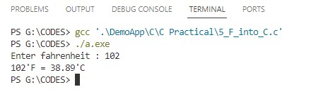**Output :**

**PRACTICAL – 6**

**Objective :-** Find Simple interest. Take Principle, Rate of interest and Time as input from user using scanf.

**Formula :** SimpleInterest = (Principal * Time * Rate) / 100

**Program :** 6_ SimpleInterest.c

# include <stdio.h>

int main ()

{

    float principal, rate, time;

    printf("Enter Principal amount : ");

    scanf("%f", &principal);

    printf("Enter rate of interest in percent : ");

    scanf("%f", &rate);

    printf("Enter time in years : ");

    scanf("%f", &time);

    float si = principal * time * rate / 100 ;

    printf("Interest earned : %.2f", si);

    printf("\n Principal Amount : %.2f", principal);

    printf("\n Total amount : %.2f", si + principal);

    return 0;

}

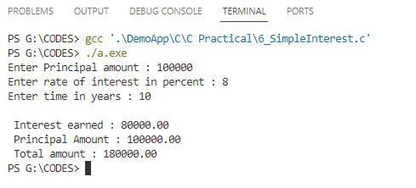**Output :**

**PRACTICAL – 7**

**Objective :-** Take a number as input from user and print it’s divisible by 19 or not using if else.

**if else :-** The if-else statement is a decision-making statement that is used to decide whether the part of the code will be executed or not based on the specified condition (test expression). If the given condition is true, then the code inside the if block is executed, otherwise the code inside the else block is executed.

**Program :** 7_Div_by_19.c

# include <stdio.h>

int main ()

{

    int x;

    printf("Enter any numder : ");

    scanf("%d", &x);

    if(x % 19 == 0){

        printf("%d is divisible by 19",x);

    } else {

        printf("%d is not divisible by 19",x);

    }

    return 0;

}

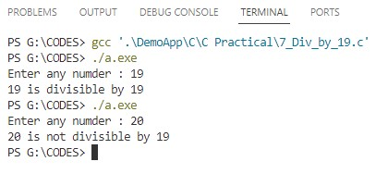**Output :**

**PRACTICAL – 8**

**Objective :-** Take a number as input from user and print it is even or odd.

**Program :** 8_Even_or_odd.c

# include <stdio.h>

int main ()

{

    int x;

    printf("Enter any numder : ");

    scanf("%d", &x);

    if(x % 2 == 0){

        printf("%d is Even number",x);

    } else {

        printf("%d is odd number",x);

    }

    return 0;

}

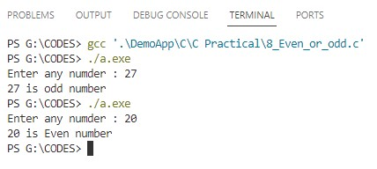**Output :**

**PRACTICAL – 9**

**Objective :-** Take marks as input from user and print it is pass or fail.

**Program :** 9_Pass_or_Fail.c

#include <stdio.h>

int main ()

{

    int x;

    printf("Enter your marks : ");

    scanf("%d",&x);

    if (x >= 0 && x < 33){

        printf("You are Fail");

    }else if(x >= 33 && x <= 100){

        printf("You are Pass");

    }else {

        printf("Invalid marks");

    }

    return 0;

}

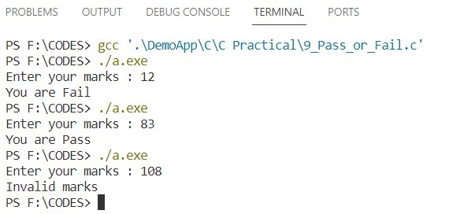**Output :**

**PRACTICAL – 10**

**Objective :-** Take percentage as input from user and print it’s grade.

0 to 32 is ‘fail’, 33 to 60 is ‘C’ grade, 61 to 80 is ‘B’ grade and 81 to 100 is ‘A’ grade

**Program :** 10_Grade.c

#include <stdio.h>

int main ()

{

    int x;

    printf("Enter your percentage : ");

    scanf("%d",&x);

    if (x >= 0 && x < 33){

        printf("You are Fail");

    }else if(x >= 33 && x <= 60){

        printf("You are Pass with C grade");

    }else if(x >= 61 && x <= 80){

        printf("You are Pass with B grade");

    }else if(x >= 81 && x <= 100){

        printf("You are Pass with A grade");

    }else {

        printf("Invalid precentage");

    }

    return 0;

}

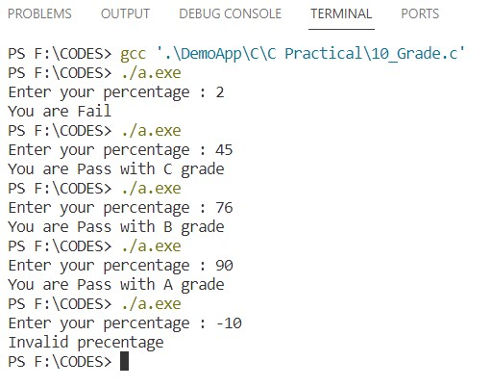**Output :**

**PRACTICAL – 11**

**Objective :-** Take year as input from user and print it was leap year or not.

**Program :** 11_leap_year.c

#include <stdio.h>

int main()

{

   int year;

   printf("Enter a year : ");

   scanf("%d",&year);

   if (year % 400 == 0) {

      printf("%d is a leap year",year);

   }

   else if (year % 100 == 0) {

      printf("%d is not a leap year",year);

   }

   else if (year % 4 == 0) {

      printf("%d is a leap year",year);

   }

   else {

      printf("%d is not a leap year",year);

   }

   return 0;

}

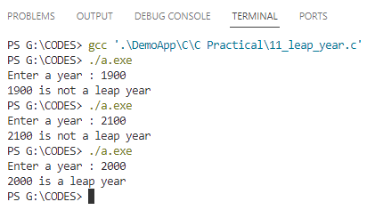**Output :**

**PRACTICAL – 12**

**Objective :-** Take a number as input from user and print there table using for loop.

**For loop** :- The **for loop** in C Language provides a functionality/feature to repeat a set of statements a defined number of times. The for loopis in itself a form of an **entry-controlled loop**.

The for loopfollows a very structured approach where it begins with initializing a condition then checks the condition and in the end executes conditional statements followed by an updation of values.

**Syntax of for Loop**

for(initialization ; check **/** test expression ; updation)

{

// body consisting of multiple statements

}

**Program :** 12_Table.c

#include <stdio.h>

int main ()

{

    int a;

    printf("Enter any number : ");

    scanf("%d",&a);

    for(int i = 1; i <= 10; i++){

        printf("%d * %d = %d\n",a,i,a*i); }

    return 0;

}

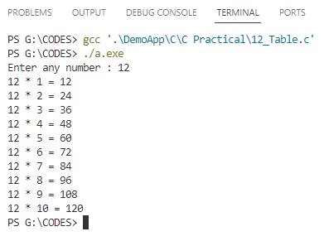**Output :**

**PRACTICAL – 13**

**Objective :-** Take a number as input from user and print prime number range till the number.

**Program :** 13_Prime_range.c

#include <stdio.h>

int main ()

{

    int x, y, count = 0;

    printf("Enter number : ");

    scanf("%d",&x);

    printf("All prime number from 1 to %d are as follows \n\n",x);

    for(int i=1; i<=x; i++){

        if(i == 5)

            printf("%d, ",i);

        if(i % 2 != 0 && i % 3 != 0 && i % 5 != 0){

            printf("%d, ",i);

            count++;

            y = 0;

        }

        if(count % 10 == 0 && y == 0){

            printf("\n");

            y = 1;

        }

    }

    return 0;

}

**Output :** 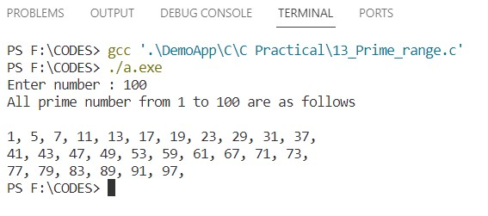

**PRACTICAL – 14**

**Objective :-** Take a number as input from user and print sum of natural number till the number using do while loop.

**Do While loop :-** The**do…while** is a loop statement used to repeat some part of the code till the given condition is fulfilled. It is a form of an **exit-controlled or post-tested loop** where the test condition is checked after executing the body of the loop. Due to this, the statements in the do…while loop will always be executed at least once no matter what the condition is.

**Syntax of do…while Loop in C**

**do** {

// body of do-while loop

} **while** (*condition*);

**Program :** 14_sum_of_natural_no.c

#include <stdio.h>

int main ()

{

    int a, count = 1, result = 0;

    printf("Enter any number : ");

    scanf("%d",&a);

    do{

        result += count;

        count++;

    }while(count != a+1);

    printf("Sum of 1 to %d is : %d",a,result);

    return 0;

}

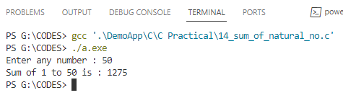**Output :**

**PRACTICAL – 15**

**Objective :-** Take a number as input from user and print the sum of table.

**Program :** 15_Sum_of_natural_no.c

#include <stdio.h>

int main ()

{

    int x, y=0;

    printf("Enter number : ");

    scanf("%d",&x);

    for(int i=1; i<=10; i++){

        y += (x * i);

    }

    printf("Sum of table of %d from %d*1 to %d*10 is :- %d",x,x,x,y);

    return 0;

}

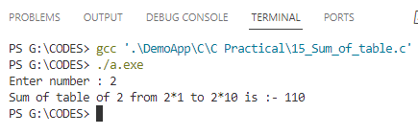**Output :**

**PRACTICAL – 16**

**Objective :-** Take a number as input from user and print it’s factorial.

**Program :** 16_factorial.c

#include <stdio.h>

int main ()

{

    int a,b=1;

    printf("Enter any number : ");

    scanf("%d",&a);

    for (int i = a; i >= 1; i--){

       b *= i;

    }

    printf("Factorial of %d is : %d",a,b);

    return 0;

}

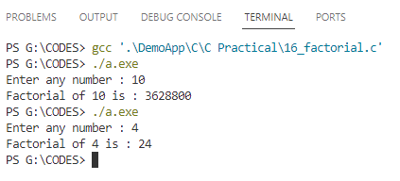**Output :**